

Investment Summary

For the month ending 31 December 2025

General Market Commentary
About Garrison Bridge

Garrison Bridge Superannuation Scheme (‘Scheme’, ‘Garrison Bridge’) is a New Zealand Superannuation Scheme, regulated by the Financial Markets Authority and offered in Australia under the Mutual Recognition Scheme. The Scheme is a managed superannuation scheme that offers seven investment options in NZD, AUD & GBP and has QROPS registration for foreign superannuation transfers.

Garrison Bridge is managed by Lifetime Asset Management Limited.

Ralph Stewart – Managing Director,
Lifetime Asset Management Limited



Ralph Stewart was CEO of AXA Insurance New Zealand for 9 years and more recently the CEO of ACC. He has thirty years of experience in New Zealand's financial services sector, including 8 years as General Manager of Marketing & Strategy at TOWER Insurance. Ralph holds a Masters in Business Administration from Manchester University in England.

Disclaimer: Past performance is not an indicator of future performance. Neither Lifetime Asset Management Limited nor any of its related companies accepts any liability for any loss or damage arising directly or indirectly out of the use of, or reliance on, the information provided in this document. Lifetime Asset Management Limited is the manager and issuer, and Public Trust is the supervisor, of the Scheme. None of Lifetime, the Government, Public Trust, or any director, board member or nominee of any of those entities, or any other person, guarantees the Schemes’ performance, returns or repayment of capital. To calculate your Prescribed Investor Rate (PIR) see the Product Disclosure Statements. The Schemes’ Product Disclosure Statements are available at garrisonbridge.co.nz
December was a mixed month for global markets as the year rounded out with investors navigating shifting signals. As we roll into 2026, it is prudent to note that equities closed 2025 near record levels globally after another solid year of gains. Investors continue to debate whether current equity valuations are justified. But concerns seem to fall on deaf ears - it is bullish momentum, solid earnings and earnings growth that have driven markets up.
In the US, markets were buoyed by a 0.25% Fed rate cut. However, diverging member views and elevated uncertainty left the future path of rates unclear. Consumer prices came in soft at 2.7% raising confidence the Fed may be on top of inflation.
Tech sentiment wavered in December after Oracle reported softer cloud computing sales and signalled plans to significantly increase AI investment. This prompted concerns about an AI bubble and triggered a tech-led pullback. In another tech development, Netflix announced it is pursuing the acquisition of Warner Bros. Discovery (and yes, this may mean more content coming to your Netflix subscription).
Here at home in NZ, we welcomed Anna Breman as our new Governor of the Reserve Bank. It wasn’t a quiet start with the Bank announcing a relaxation of capital requirements and Breman highlighting risks around a sharp rise in market interest rates. GDP for the September quarter rose 1.1%, offering a welcome lift in economic sentiment.
Meanwhile, the New Zealand Treasury’s Half Year Economic and Fiscal Update extended the timeline for the Government’s return to surplus by another year. As New Zealand heads into an election year, political signals are becoming increasingly relevant.
Across the Tasman, Australian GDP grew 0.4% in Q3, undershooting expectations. The RBA maintained a hawkish stance, holding the cash rate at 3.6% and reiterating that inflation risks remain skewed to the upside. Despite this, equity markets held up reasonably well, though consumer confidence stayed subdued.
Against this backdrop, the S&P 500 finished the month broadly flat. The tech-heavy NASDAQ slipped -0.5% amid tech volatility. The FTSE 100 outperformed, rising 2.2% as UK inflation surprised to the downside and the Bank of England cut rates. Closer to home, the NZX 50 and ASX 200 returned 0.4% and 1.2% respectively.
GBP and AUD / NZD exchange rate change from 30 November 2025 to 31 December 2025:

GBP and AUD / NZD exchange rate change from 31 December 2024 to 31 December 2025:
The exchange rates are sourced from Reuters (https://www.reuters.com/markets/currencies/)

Fund Summary
For the month ending 31 December 2025

NZD Conservative Fund

Description of this Fund
Target asset allocation

Underlying Fund Managers
Simplicity NZ Limited is a leading investment manager located in NZ, with over NZ$9 billion under management.
Harbour Asset Management Limited is a proven fund manager with approximately NZ$19 billion of funds under management.
Smartshares Limited is New Zealand’s only issuer of ETFs listed on the NZX Main Board, with over NZ$15 billion of funds under management.
Mercer (N.Z.) Limited is part of Marsh & McLennan Companies, Inc with a global investment network, managing approximately US$650 billion.
Key facts
Inception date:
24 December 2018

Underlying Investment Managers:
Simplicity NZ Limited, Harbour Asset Management Limited, Smartshares Limited, and Mercer (N.Z.) Limited

Supervisor:
Public Trust

Fund type:
Multi-rate Portfolio Investment Entity

Licensed Manager:
Lifetime Asset Management Limited
Estimated annual fund charge: 1.09%
Disclaimer: Past performance is not an indicator of future performance. Neither Lifetime Asset Management Limited nor any of its related companies accepts any liability for any loss or damage arising directly or indirectly out of the use of, or reliance on, the information provided in this document. Lifetime Asset Management Limited is the manager and issuer, and Public Trust is the supervisor, of the Scheme. None of Lifetime, the Government, Public Trust, or any director, board member or nominee of any of those entities, or any other person, guarantees the Schemes’ performance, returns or repayment of capital. To calculate your Prescribed Investor Rate (PIR) see the Product Disclosure Statements. The Schemes’ Product Disclosure Statements are available at garrisonbridge.co.nz

New Zealand Dollar denominated fund employing an active asset allocation strategy and a passive investment management strategy invested 70% in income assets (New Zealand and international fixed interest), with 30% exposure to growth assets (Australasian and international equities). Seeks to track composite indices (before annual fund charge and tax), comprising: 10% S&P/NZX Bank Bills 90-Day Index; 40% Bloomberg NZ Bond Govt 0+ Yr Index; 20% Bloomberg Global Aggregate Index, 100% hedged to NZD; 20% Morningstar New Zealand (total return) Index, including imputation credits; 5% MSCI World Index NR ex NZ, Tobacco, Controversial and Nuclear Weapons; and 5% MSCI World Index NR ex NZ, Tobacco, Controversial and Nuclear Weapons, 100% hedged to NZD.

Risk indicator for the NZD Conservative Fund

⬅ Potentially lower returns Potentially higher returns ➔

1 | 2 | 3 | 4 | 5 | 6 | 7
⬅ Lower risk Higher risk ➔

The risk indicator is rated from 1 (low) to 7 (high). The rating reflects how much the value of the Fund’s assets goes up and down. A higher risk generally means higher potential returns over time, but more ups and downs along the way. For further information on how the risk indicator is calculated, please see the Passively Managed Fund Options Product Disclosure Statement.

Investment performance
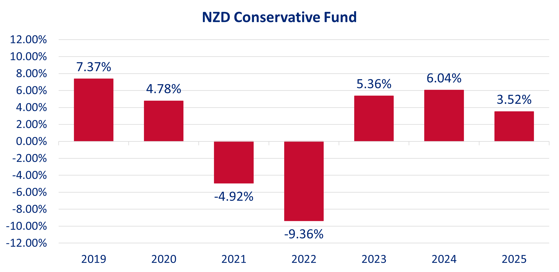
The chart below shows the fund return after fund charges and tax (at 28%) for each full calendar year the fund has been in existence. The last bar shows the performance of the current calendar year to date (1 January 2025 to 31 December 2025).

See the below performance figures for the NZD Conservative Fund as at 31 December 2025. The returns are after fees and after taxes:
PIR Tax Rate | Month | Quarter | 12-months |  | 3-year | 5-year | Inception
28% | 0.06% | 0.47% | 3.52% |  | 4.97% | -0.07% | 1.66%
0% | 0.06% | 0.46% | 4.32% |  | 5.83% | -0.08% | 1.94%
Returns for periods longer than one year are annualised

Fund Summary
For the month ending 31 December 2025

NZD Growth Fund

Description of this Fund
Target asset allocation

Underlying Fund Managers

Simplicity NZ Limited is a leading investment manager located in NZ, with over NZ$9 billion under management.
Harbour Asset Management Limited is a proven fund manager with approximately NZ$19 billion of funds under management.
Smartshares Limited is New Zealand’s only issuer of ETFs listed on the NZX Main Board, with over NZ$15 billion of funds under management.
Mercer (N.Z.) Limited is part of Marsh & McLennan Companies, Inc with a global investment network, managing approximately US$650 billion.
Key facts
Inception date:
24 December 2018

Underlying Investment Managers:
Simplicity NZ Limited, Harbour Asset Management Limited, Smartshares Limited, and Mercer (N.Z.) Limited

Supervisor:
Public Trust

Fund type:
Multi-rate Portfolio Investment Entity

Licensed Manager:
Lifetime Asset Management Limited
Estimated annual fund charge: 1.09%

Disclaimer: Past performance is not an indicator of future performance. Neither Lifetime Asset Management Limited nor any of its related companies accepts any liability for any loss or damage arising directly or indirectly out of the use of, or reliance on, the information provided in this document. Lifetime Asset Management Limited is the manager and issuer, and Public Trust is the supervisor, of the Scheme. None of Lifetime, the Government, Public Trust, or any director, board member or nominee of any of those entities, or any other person, guarantees the Schemes’ performance, returns or repayment of capital. To calculate your Prescribed Investor Rate (PIR) see the Product Disclosure Statements. The Schemes’ Product Disclosure Statements are available at garrisonbridge.co.nz
New Zealand Dollar denominated fund employing an active asset allocation strategy and a passive investment management strategy invested 16% in income assets (New Zealand and international fixed interest), with 84% exposure to growth assets (Australasian and international equities). Seeks to track composite indices (before annual fund charge and tax), comprising: 8% Bloomberg NZ Bond Govt 0+ Yr Index; 8% Bloomberg Global Aggregate Index, 100% hedged to NZD; 15% Morningstar New Zealand (total return) Index, including imputation credits; 15% S&P/NZX 50 Portfolio Index, including imputation credits; 27% MSCI World Index NR ex NZ, Tobacco, Controversial and Nuclear Weapons; and 27% MSCI World Index NR ex NZ, Tobacco, Controversial and Nuclear Weapons, 100% hedged to NZD.

Risk indicator for the NZD Growth Fund

⬅ Potentially lower returns Potentially higher returns ➔

1 | 2 | 3 | 4 | 5 | 6 | 7
⬅ Lower risk Higher risk ➔

The risk indicator is rated from 1 (low) to 7 (high). The rating reflects how much the value of the Fund’s assets goes up and down. A higher risk generally means higher potential returns over time, but more ups and downs along the way. For further information on how the risk indicator is calculated, please see the Passively Managed Fund Options Product Disclosure Statement.

Investment performance
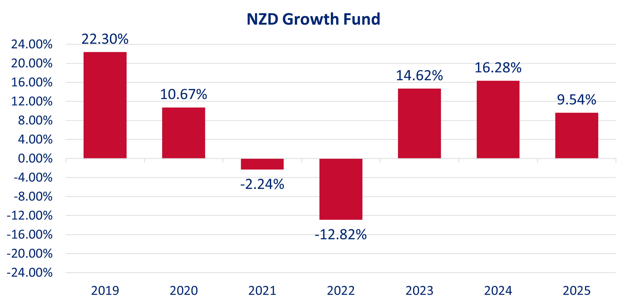
The chart below shows the fund return after fund charges and tax (at 28%) for each full calendar year the fund has been in existence. The last bar shows the performance of the current calendar year to date (1 January 2025 to 31 December 2025).

See the below performance figures for the NZD Growth Fund as at 31 December 2025. The returns are after fees and after taxes:
PIR Tax Rate | Month | Quarter | 12-months |  | 3-year | 5-year | Inception
28% | 0.24% | 2.11% | 9.54% |  | 13.44% | 4.47% | 7.74%
0% | 0.30% | 2.26% | 10.56% |  | 14.52% | 5.15% | 8.47%
Returns for periods longer than one year are annualised
=

Fund Summary
For the month ending 31 December 2025

AUD Balanced Fund

Description of this Fund
Target asset allocation

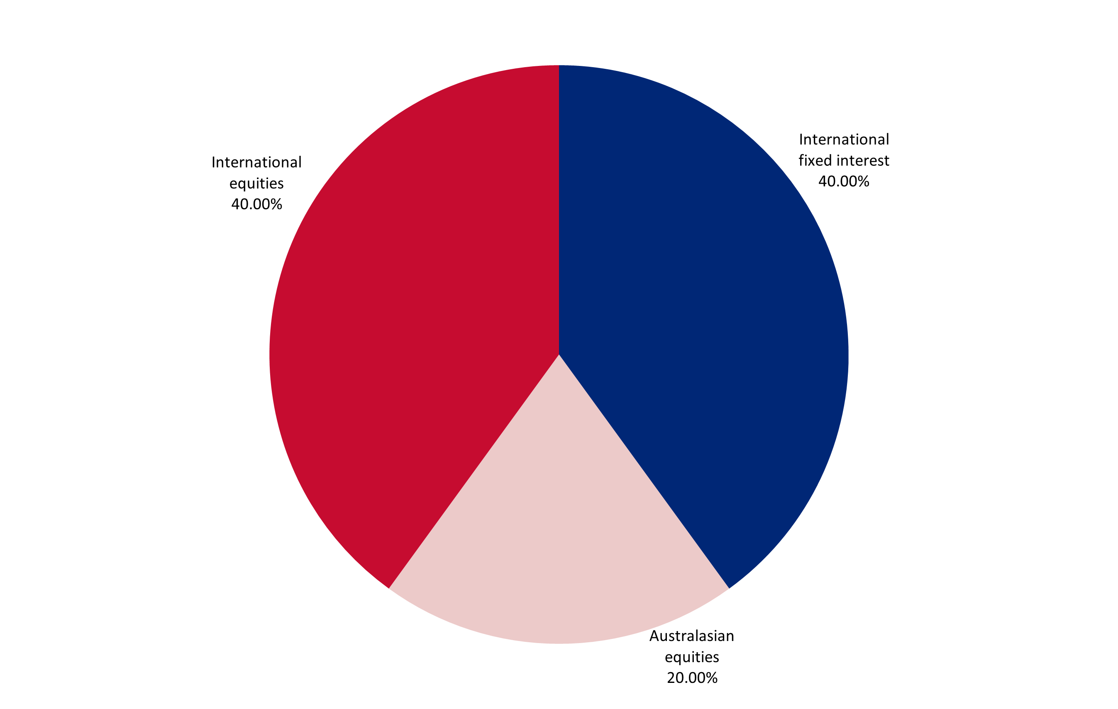
Underlying Fund Managers
Vanguard Investments Australia Limited. The Vanguard Group, Inc is the world’s second largest investment manager with over US$10 trillion under management.
BlackRock Investment Management (Australia) Limited. BlackRock, Inc is the world’s largest global investment manager with over US$12 trillion in assets under management.

Key facts
Inception date:
24 December 2018

Underlying Investment Managers:
Vanguard Investments Australia Limited, BlackRock Investment Management (Australia) Limited

Supervisor:
Public Trust

Fund type:
Multi-rate Portfolio Investment Entity

Licensed Manager:
Lifetime Asset Management Limited
Estimated annual fund charge: 1.19%

Disclaimer: Past performance is not an indicator of future performance. Neither Lifetime Asset Management Limited nor any of its related companies accepts any liability for any loss or damage arising directly or indirectly out of the use of, or reliance on, the information provided in this document. Lifetime Asset Management Limited is the manager and issuer, and Public Trust is the supervisor, of the Scheme. None of Lifetime, the Government, Public Trust, or any director, board member or nominee of any of those entities, or any other person, guarantees the Schemes’ performance, returns or repayment of capital. To calculate your Prescribed Investor Rate (PIR) see the Product Disclosure Statements. The Schemes’ Product Disclosure Statements are available at garrisonbridge.co.nz
Australian Dollar denominated fund employing an active asset allocation strategy and a passive investment management strategy invested 40% in income assets (international fixed interest), with 60% exposure to growth assets (Australasian and international equities). Seeks to track composite indices (before annual fund charge and tax), comprising: 20% Bloomberg Aus Bond Credit 0+ Yr Index; 20% Bloomberg Global Treasury Scaled Index, 100% hedged to AUD; 20% FTSE Australia 300 Choice Index; and 40% MSCI World ex Australia Custom ESG Leaders Index, 100% hedged to AUD.

Risk indicator for the AUD Balanced Fund

⬅ Potentially lower returns Potentially higher returns ➔

1 | 2 | 3 | 4 | 5 | 6 | 7
⬅ Lower risk Higher risk ➔

The risk indicator is rated from 1 (low) to 7 (high). The rating reflects how much the value of the Fund’s assets goes up and down. A higher risk generally means higher potential returns over time, but more ups and downs along the way. For further information on how the risk indicator is calculated, please see the Passively Managed Fund Options Product Disclosure Statement.

Investment performance
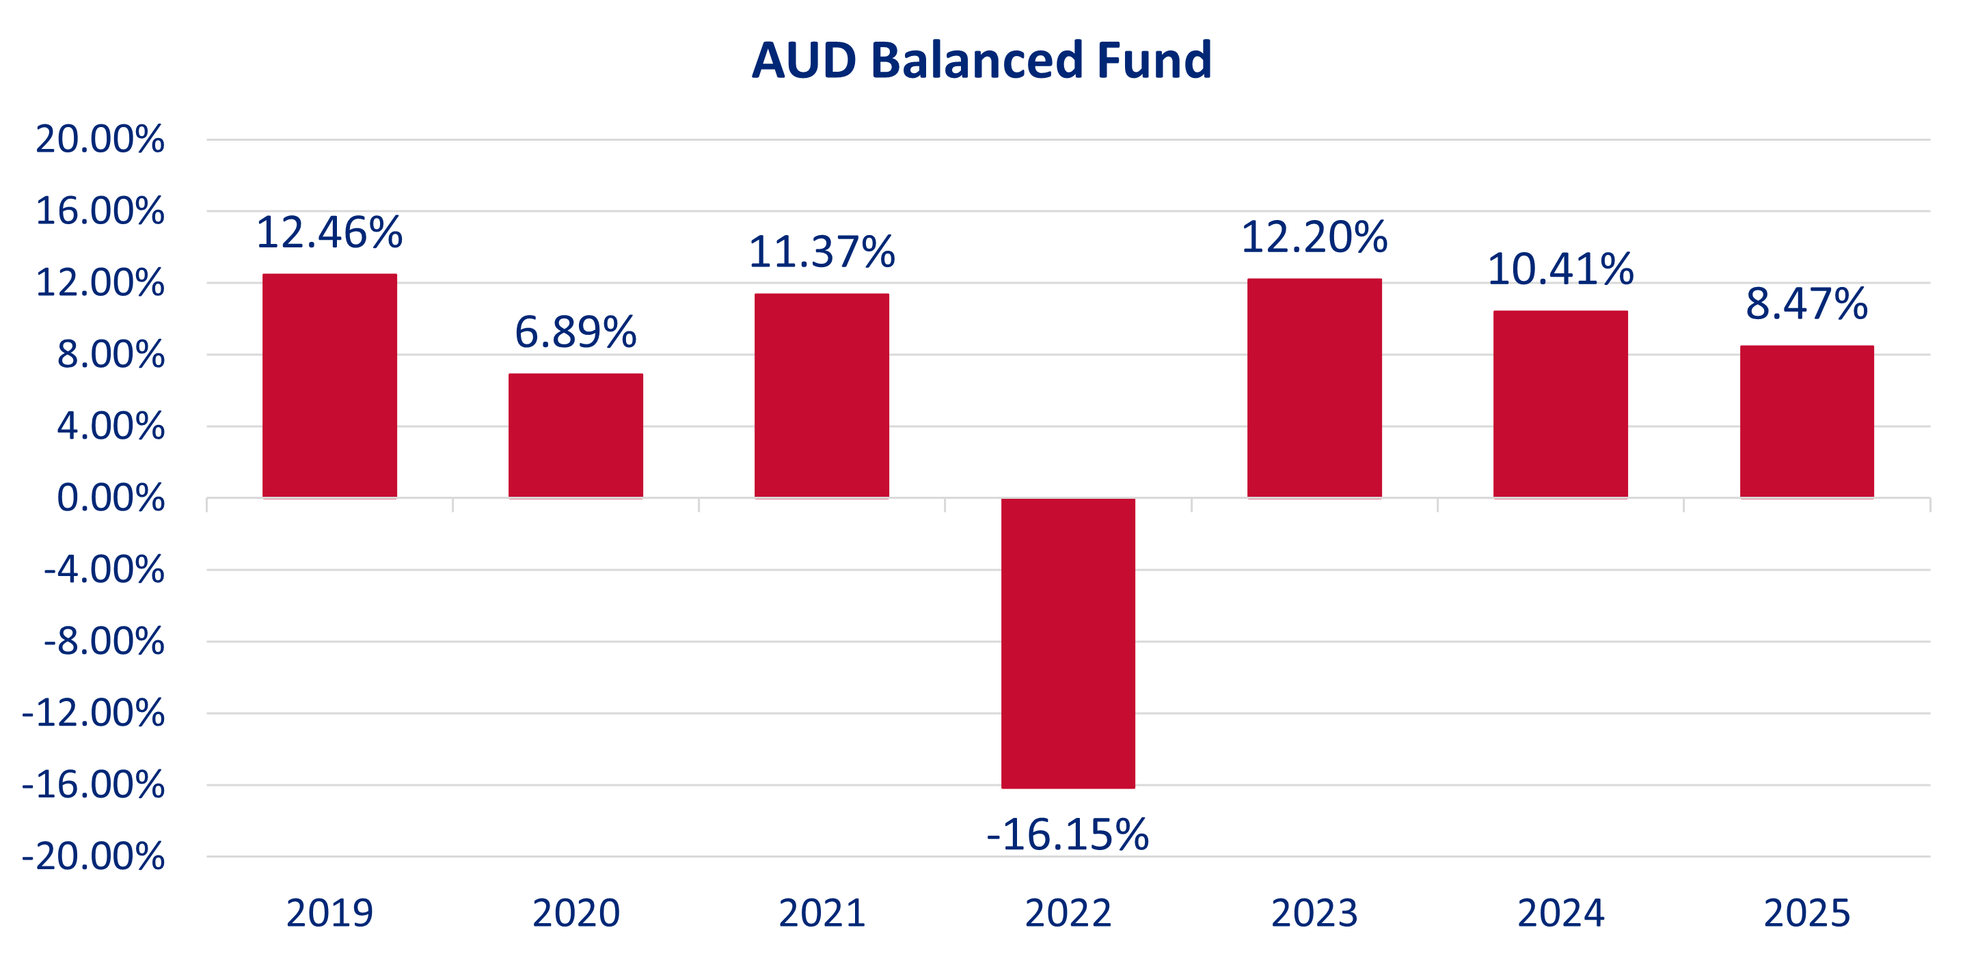
The chart below shows the fund return after fund charges and tax (at 28%) for each full calendar year the fund has been in existence. The last bar shows the performance of the current calendar year to date (1 January 2025 to 31 December 2025).

See the below performance figures for the AUD Balanced Fund as at 31 December 2025. The returns are after fees and after taxes:
PIR Tax Rate | Month | Quarter | 12-months |  | 3-year | 5-year | Inception
28% | 0.63% | 0.98% | 8.47% |  | 10.35% | 4.64% | 6.03%
0% | 0.73% | 1.26% | 9.69% |  | 11.58% | 5.79% | 7.18%
Returns for periods longer than one year are annualised

Fund Summary
For the month ending 31 December 2025

GBP Conservative Fund

Description of this Fund
Target asset allocation

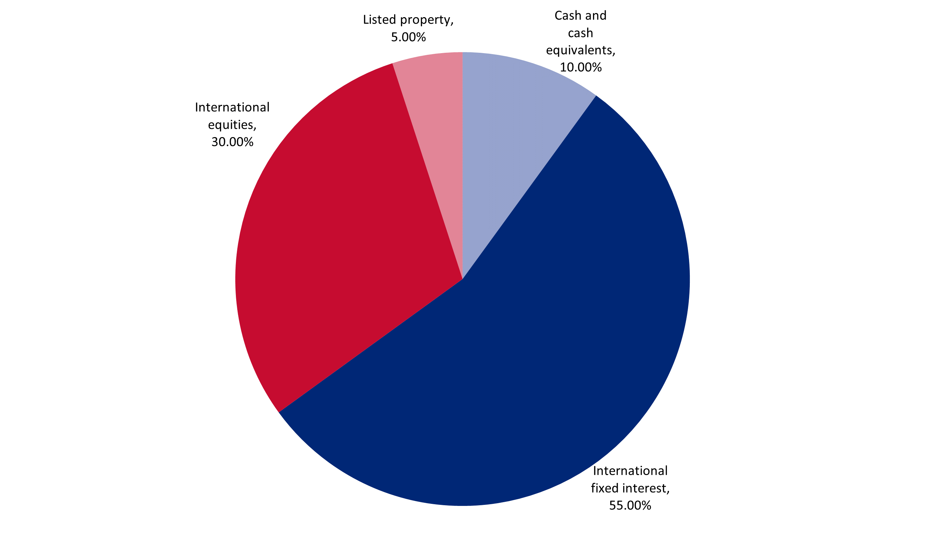
Underlying Fund Manager
BlackRock Asset Management Ireland Limited. BlackRock, Inc is the world’s largest global investment manager with over US$12 trillion in assets under management. BlackRock is an American global investment management corporation based in New York. It was founded in 1988, initially as a risk management and fixed income institutional asset manager.
Vanguard Group (Ireland) Limited. The Vanguard Group, Inc is the world’s second largest investment manager with over US$10 trillion under management.
Key facts
Inception date:
24 December 2018

Underlying Investment Manager:
BlackRock Asset Management Ireland Limited, Vanguard Group (Ireland) Limited

Supervisor:
Public Trust

Fund type:
Multi-rate Portfolio Investment Entity

Licensed Manager:
Lifetime Asset Management Limited
Estimated annual fund charge: 1.14%

Disclaimer: Past performance is not an indicator of future performance. Neither Lifetime Asset Management Limited nor any of its related companies accepts any liability for any loss or damage arising directly or indirectly out of the use of, or reliance on, the information provided in this document. Lifetime Asset Management Limited is the manager and issuer, and Public Trust is the supervisor, of the Scheme. None of Lifetime, the Government, Public Trust, or any director, board member or nominee of any of those entities, or any other person, guarantees the Schemes’ performance, returns or repayment of capital. To calculate your Prescribed Investor Rate (PIR) see the Product Disclosure Statements. The Schemes’ Product Disclosure Statements are available at garrisonbridge.co.nz

Great British Pound denominated fund employing an active asset allocation strategy and a passive investment management strategy invested 65% in income assets (international fixed interest and cash and cash equivalents), with 35% exposure to growth assets (international equities and listed property). Seeks to track composite indices (before annual fund charge and tax), comprising: 10% Markit iBoxx GBP Liquid Investment Grade Ultrashort Index; 41% Bloomberg Global Aggregate Corporate Index, 100% hedged to GBP; 14% Bloomberg Global Aggregate Float Adjusted and Scaled Index, 100% hedged to GBP; 5% FTSE EPRA/NAREIT UK Index; 22.5% MSCI World ESG Screened Net GBP; and 7.5% FTSE Developed Index..

Risk indicator for the GBP Conservative Fund

⬅ Potentially lower returns Potentially higher returns ➔

1 | 2 | 3 | 4 | 5 | 6 | 7
⬅ Lower risk Higher risk ➔

The risk indicator is rated from 1 (low) to 7 (high). The rating reflects how much the value of the Fund’s assets goes up and down. A higher risk generally means higher potential returns over time, but more ups and downs along the way. For further information on how the risk indicator is calculated, please see the Passively Managed Fund Options Product Disclosure Statement.

Investment performance
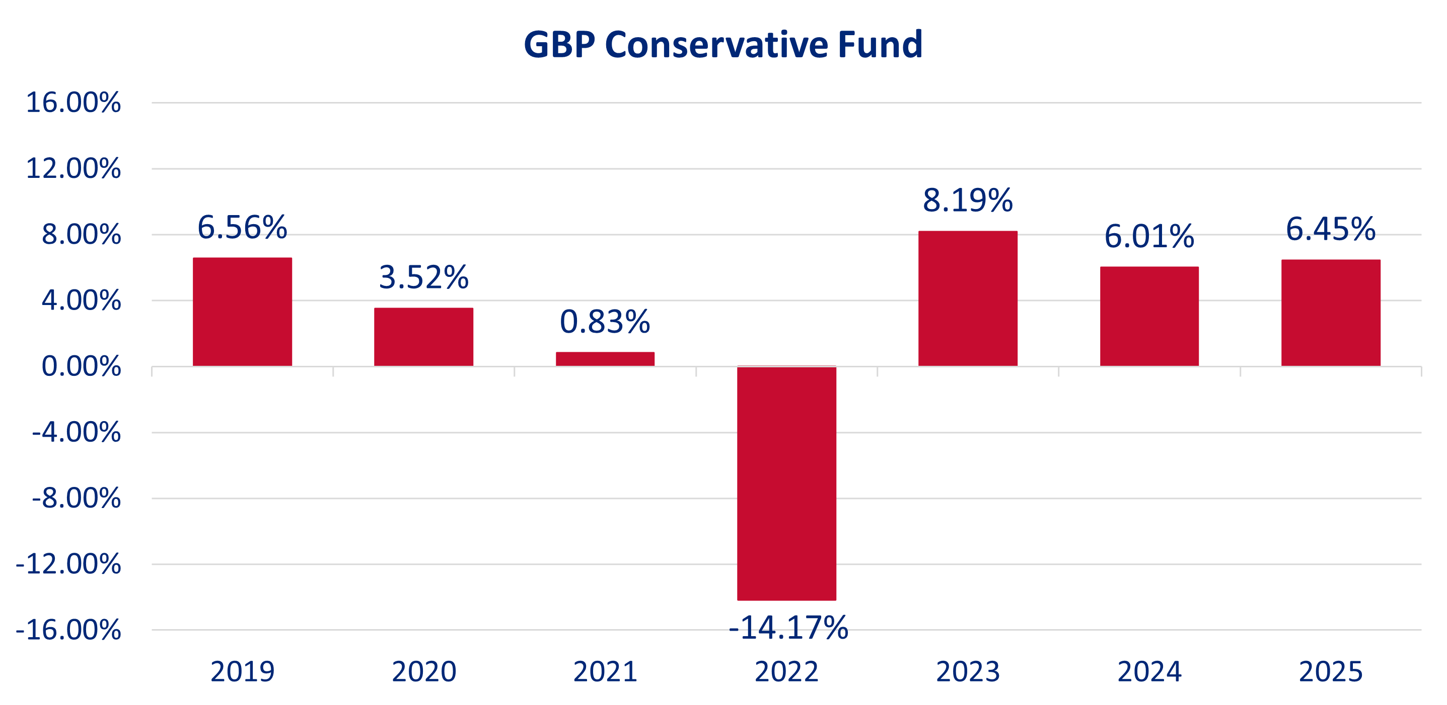
The chart below shows the fund return after fund charges and tax (at 28%) for each full calendar year the fund has been in existence. The last bar shows the performance of the current calendar year to date (1 January 2025 to 31 December 2025).

See the below performance figures for the GBP Conservative Fund as at 31 December 2025. The returns are after fees and after taxes:
PIR Tax Rate | Month | Quarter | 12-months | 3-year | 5-year | Inception
28% | -0.18% | 1.46% | 6.45% | 6.88% | 1.11% | 2.20%
0% | -0.08% | 1.75% | 7.65% | 8.09% | 2.23% | 3.32%
Returns for periods longer than one year are annualised

Fund Summary
For the month ending 31 December 2025

GBP Balanced Fund



Description of this Fund
Target asset allocation

Underlying Fund Manager
BlackRock Asset Management Ireland Limited. BlackRock, Inc is the world’s largest global investment manager with over US$12 trillion in assets under management. BlackRock is an American global investment management corporation based in New York. It was founded in 1988, initially as a risk management and fixed income institutional asset manager.
Vanguard Group (Ireland) Limited. The Vanguard Group, Inc is the world’s second largest investment manager with over US$10 trillion under management.
Key facts
Inception date:
1 August 2022

Underlying Investment Manager:
BlackRock Asset Management Ireland Limited, Vanguard Group (Ireland) Limited

Supervisor:
Public Trust

Fund type:
Multi-rate Portfolio Investment Entity

Licensed Manager:
Lifetime Asset Management Limited
Estimated annual fund charge: 1.19%

Disclaimer: Past performance is not an indicator of future performance. Neither Lifetime Asset Management Limited nor any of its related companies accepts any liability for any loss or damage arising directly or indirectly out of the use of, or reliance on, the information provided in this document. Lifetime Asset Management Limited is the manager and issuer, and Public Trust is the supervisor, of the Scheme. None of Lifetime, the Government, Public Trust, or any director, board member or nominee of any of those entities, or any other person, guarantees the Schemes’ performance, returns or repayment of capital. To calculate your Prescribed Investor Rate (PIR) see the Product Disclosure Statements. The Schemes’ Product Disclosure Statements are available at garrisonbridge.co.nz

Great British Pound denominated fund employing an active asset allocation strategy and a passive investment management strategy invested 50% in income assets (cash and cash equivalents and international fixed interest), with 50% exposure to growth assets (listed property and international equities). Seeks to track composite indices (before annual fund charge and tax), comprising: 5% Markit iBoxx GBP Liquid Investment Grade Ultrashort Index; 34% Bloomberg Global Aggregate Corporate Index 100% hedged to GBP; 11% Bloomberg Global Aggregate Float Adjusted and Scaled Index, 100% hedged to GBP; 5% FTSE EPRA/NAREIT UK Index; 34% MSCI World ESG Screened Index Net GBP; and 11% FTSE Developed Index.

Risk indicator for the GBP Balanced Fund

⬅ Potentially lower returns Potentially higher returns ➔

1 | 2 | 3 | 4 | 5 | 6 | 7
⬅ Lower risk Higher risk ➔

The risk indicator is rated from 1 (low) to 7 (high). The rating reflects how much the value of the Fund’s assets goes up and down. A higher risk generally means higher potential returns over time, but more ups and downs along the way. For further information on how the risk indicator is calculated, please see the Passively Managed Fund Options Product Disclosure Statement.

Investment performance
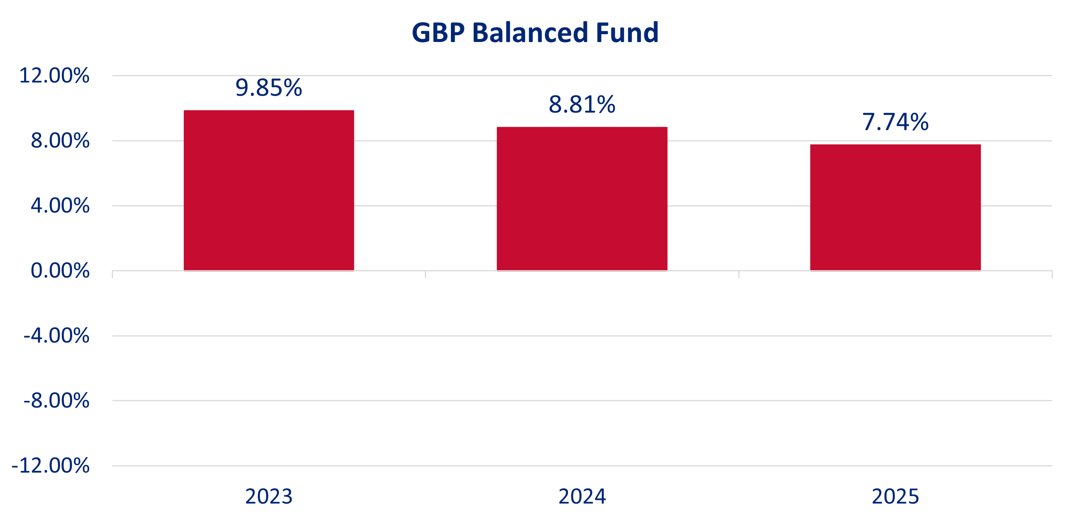
The chart below shows the fund return after fund charges and tax (at 28%) for each full calendar year the fund has been in existence. The last bar shows the performance of the current calendar year to date (1 January 2025 to 31 December 2025).

See the below performance figures for the GBP Balanced Fund as at 31 December 2025. The returns are after fees and after taxes:
PIR Tax Rate | Month | Quarter | 12-months | 3-year | 5-year | Inception
28% | -0.22% | 1.88% | 7.74% | 8.80% | - | 5.81%
0% | -0.12% | 2.17% | 8.96% | 10.03% | - | 6.99%
Returns for periods longer than one year are annualised

Fund Summary
For the month ending 31 December 2025

GBP Growth Fund

Description of this Fund
Target asset allocation
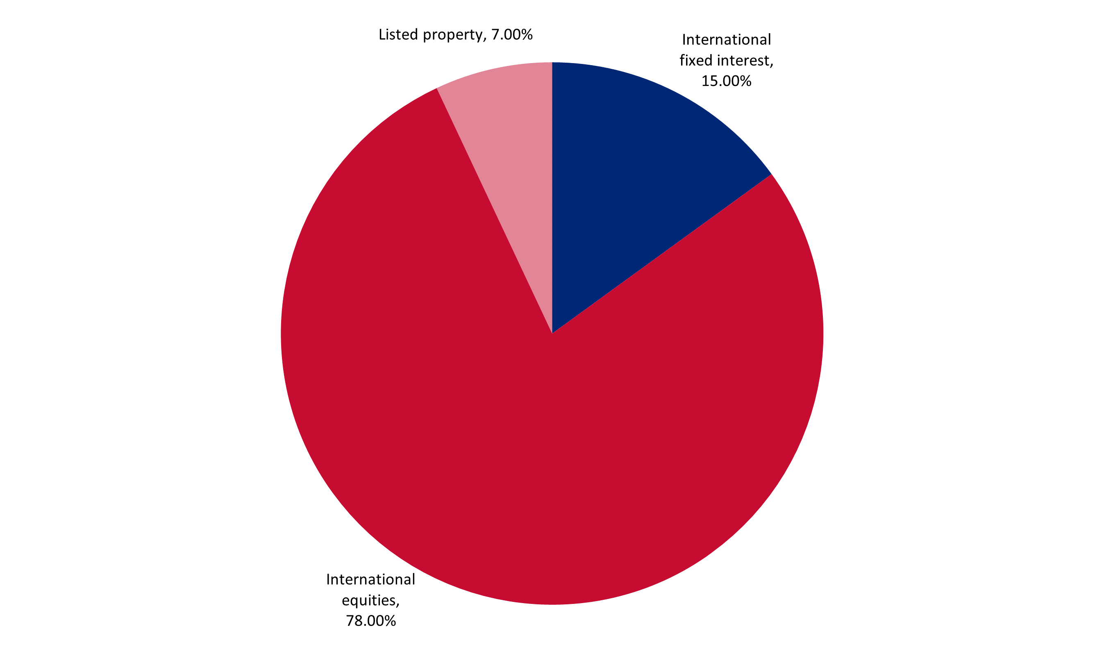Underlying Fund Manager
BlackRock Asset Management Ireland Limited. BlackRock, Inc is the world’s largest global investment manager with over US$12 trillion in assets under management. BlackRock is an American global investment management corporation based in New York. It was founded in 1988, initially as a risk management and fixed income institutional asset manager.
Vanguard Group (Ireland) Limited. The Vanguard Group, Inc is the world’s second largest investment manager with over US$10 trillion under management.
Key facts
Inception date:
24 December 2018

Underlying Investment Manager:
BlackRock Asset Management Ireland Limited, Vanguard Group (Ireland) Limited

Supervisor:
Public Trust

Fund type:
Multi-rate Portfolio Investment Entity

Licensed Manager:
Lifetime Asset Management Limited
Estimated annual fund charge: 1.19%
Disclaimer: Past performance is not an indicator of future performance. Neither Lifetime Asset Management Limited nor any of its related companies accepts any liability for any loss or damage arising directly or indirectly out of the use of, or reliance on, the information provided in this document. Lifetime Asset Management Limited is the manager and issuer, and Public Trust is the supervisor, of the Scheme. None of Lifetime, the Government, Public Trust, or any director, board member or nominee of any of those entities, or any other person, guarantees the Schemes’ performance, returns or repayment of capital. To calculate your Prescribed Investor Rate (PIR) see the Product Disclosure Statements. The Schemes’ Product Disclosure Statements are available at garrisonbridge.co.nz

Great British Pound denominated fund employing an active asset allocation strategy and a passive investment management strategy invested 15% in income assets (international fixed interest), with 85% exposure to growth assets (listed property and international equities). Seeks to track composite indices (before annual fund charge and tax), comprising: 11% Bloomberg Global Aggregate Corporate Index, 100% hedged to GBP; 4% Bloomberg Global Aggregate Float Adjusted and Scaled Index, 100% hedged to GBP; 7% FTSE EPRA/NAREIT UK Index; 58.5% MSCI World ESG Screened Index Net GBP; and 19.5% FTSE Developed Index.

Risk indicator for the GBP Growth Fund

⬅ Potentially lower returns Potentially higher returns ➔

1 | 2 | 3 | 4 | 5 | 6 | 7
⬅ Lower risk Higher risk ➔

The risk indicator is rated from 1 (low) to 7 (high). The rating reflects how much the value of the Fund’s assets goes up and down. A higher risk generally means higher potential returns over time, but more ups and downs along the way. For further information on how the risk indicator is calculated, please see the Passively Managed Fund Options Product Disclosure Statement.

Investment performance
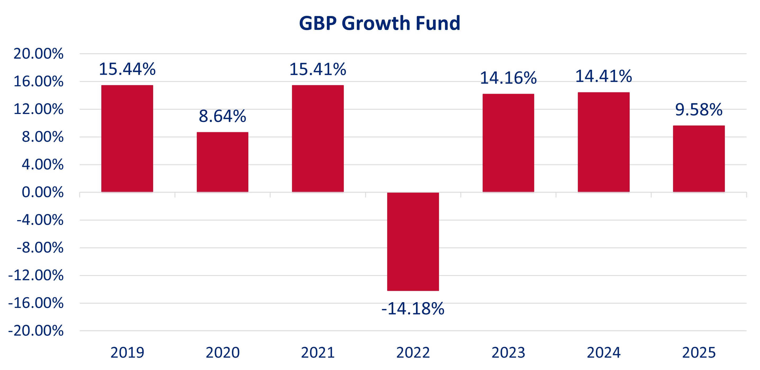
The chart below shows the fund return after fund charges and tax (at 28%) for each full calendar year the fund has been in existence. The last bar shows the performance of the current calendar year to date (1 January 2025 to 31 December 2025).

See the below performance figures for the GBP Growth Fund as at 31 December 2025. The returns are after fees and after taxes:
PIR Tax Rate | Month | Quarter | 12-months |  | 3-year | 5-year | Inception
28% | -0.29% | 2.94% | 9.58% |  | 12.69% | 7.23% | 8.53%
0% | -0.19% | 3.23% | 10.82% |  | 13.97% | 8.42% | 9.72%
Returns for periods longer than one year are annualized

5

